Lab_Day-9 (String Methods)

1. Write a Python program to Count all letters, digits, and special symbols from the given string

Input = “P@#yn26at^&i5ve”

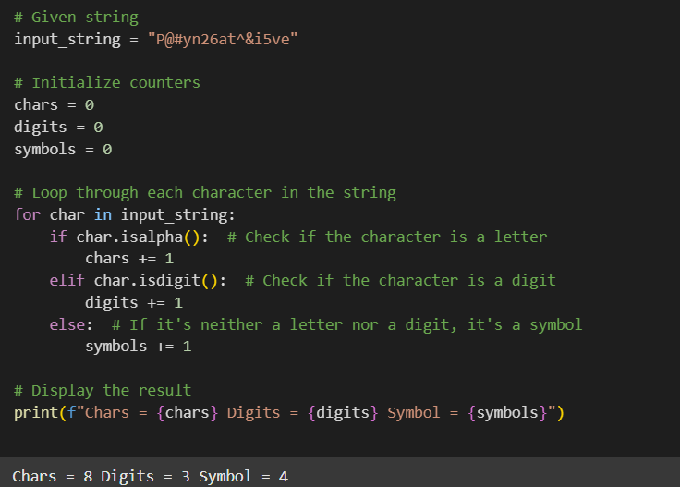

1. Write a Python program to remove duplicate characters of a given string.

Input = “String and String Function”

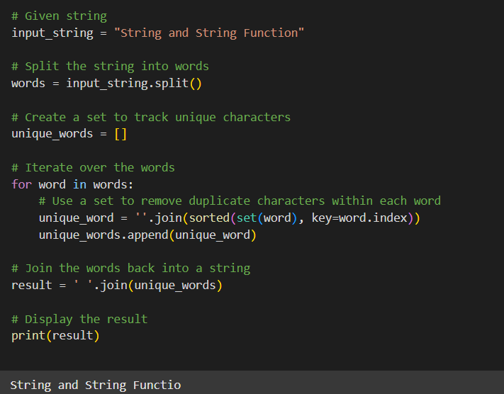

1. Write a Python program to count Uppercase, Lowercase, special character and numeric values in a given string

Input = “Hell0 W0rld ! 123 * # welcome to pYtHoN”

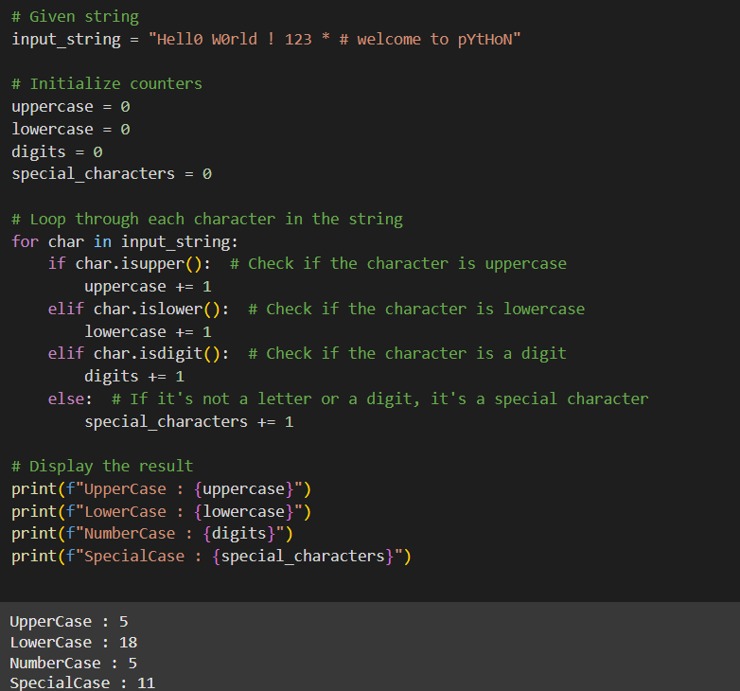

1. Write a Python Count vowels in a string

input= “Welcome to Python Assignment”

